LAB # 05
Working with Flowcharts using Microsoft Visio

Introduction
Microsoft Office Visio is drawing and diagramming software that helps transform concepts into a visual representation. Here we are going to focus on how to create a logical diagram and flow chart when drawn in Visio.
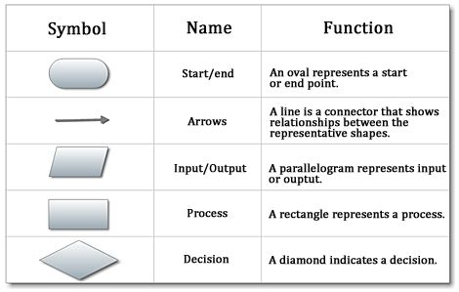

Flow chart
Step 1: From the categories areas select Basic Flow Chart, and select Flow Chart.
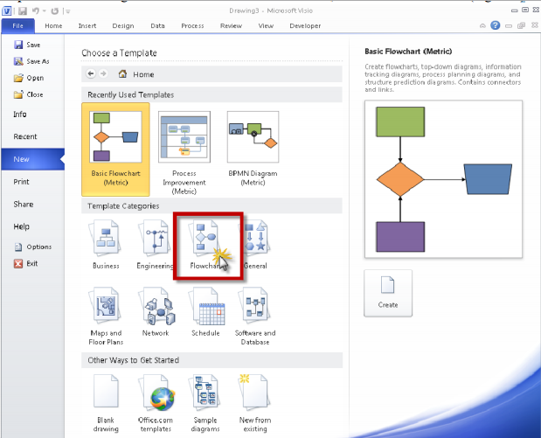

Step 2: Double click on Flow Chart, you will see Visio Screen Layout.
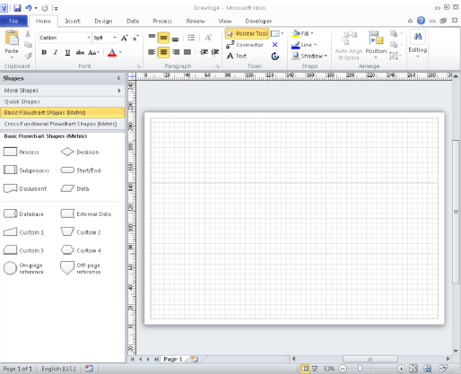

Working with Shapes from a Basic Flow chart Template:

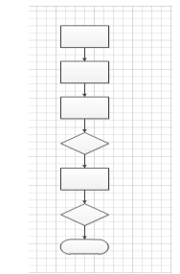

Layout your screen as follows
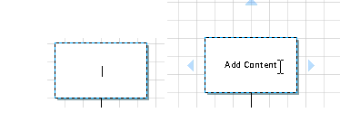
Adding Text to the shape

Adding the Connector
a. Select the Diamond Shape
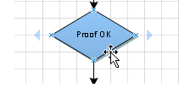

b. Select the connector tool button from the home tab
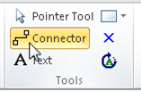

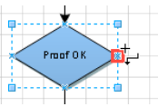
c. Move the mouse to the position shown below note the cursor has changed to reveal the connector tool. As you position to a point you can connect to the shape a small red square will appear.

d. Depress the left mouse key and drag the mouse pointer to the center left edge connection point of the shape above.
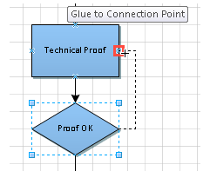

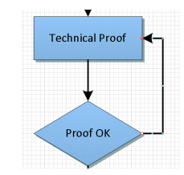
e. Release the mouse Button and you will see a connector from the diamond to the rectangle above and shown.

Add text to connectors
a. Double click on the connector line to type in text.
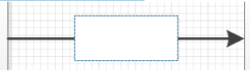


b. Enter your required text then click away from the Line

c. Layout Document as below.
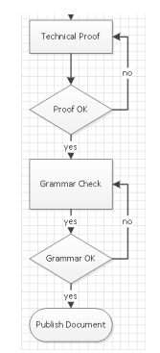

Lab Tasks
Draw flowcharts for the following Scenarios:
Task 1: Ordering a book
Task 2: Taking Admission in university
Task 3: Fee payment procedure in a university
Task 4: Reporting a crime in police station
Task 5: Hiring a cab

